75-Year-old memories of time spent as a member of the
1st Streatham Common Scout Group
By Dave Brown
I saw your posting about the 1st Streatham Common Scout Group on Facebook about looking for past members of the group.
We were sorting out photos of the past 70 years recently and came across these and I wondered then how we could contact the current leaders in case they were interested.
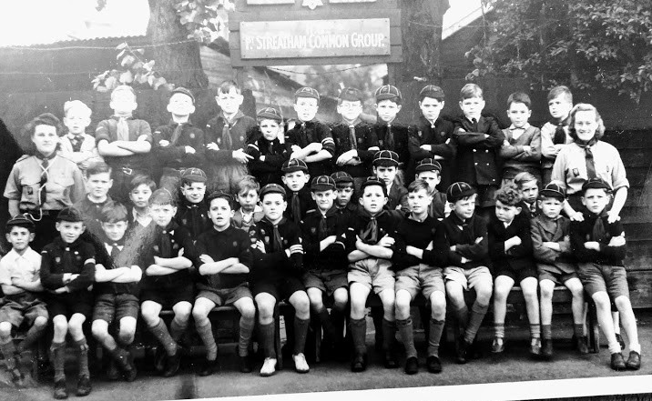
I lived off Streatham Vale and joined the Wolf Cubs in 1946/7. I enclose a photo, above, of the group taken about then. Akela and Baloo are at either end. I’ve no idea of their real names of course. I am in the centre of the second row.
The second photo, below, is at a camp in 1955. I am on the right in the jumper with the badge on, knitted by my Mum.
Next to me is the Scout Master, Mr Price, nicknamed “Ticket” and the Assistant Scout Master is from memory, Mr Kingham.
The Scout Master in the 1940s was “Skip” Tyler and the Group Scout Master was Mr Frankham in the 1940s and 1950s.
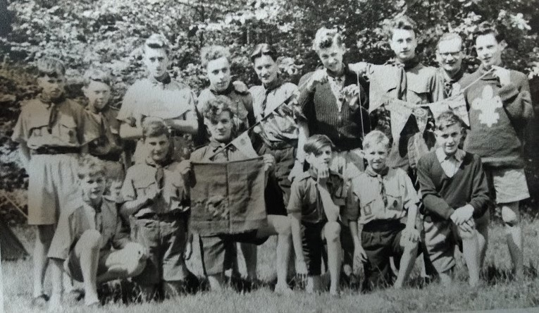
The boy with the flag is John Gilchrist and behind him Bernard …….. . I'm not very good at remembering names. John's surname came to me in the middle of the night. A few more good nights sleep and I might recall some more.
The third photo, right, is at a CoH , Patrol Leaders and Assistant Patrol Leaders camp in 1955 at Broadstone Warren, Forest Row, going by bike carrying all the equipment. Tents weren't very lightweight then.  We went on summer camps to various places.  The troop was about 20/25 strong but had few senior scouts. | 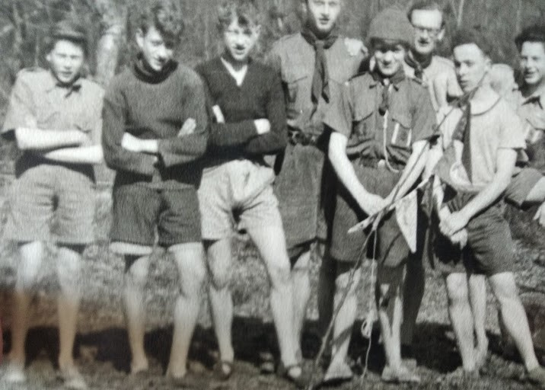
After the war the hut near the gate was used for storing collected newspapers which were sold for funds.
The families used to organise Whist drives and Jumble Sales too.
I left scouting in 1956.
My brother, Allan, was also in the group which he joined in 1939. After doing his National Service, he came back as a leader taking out a warrant at age 21 in 1953 which he held almost continuously until he was 70. He moved away for work in 1954 and started a troop. After 15 years, he moved again for work and started up another troop in his new location.
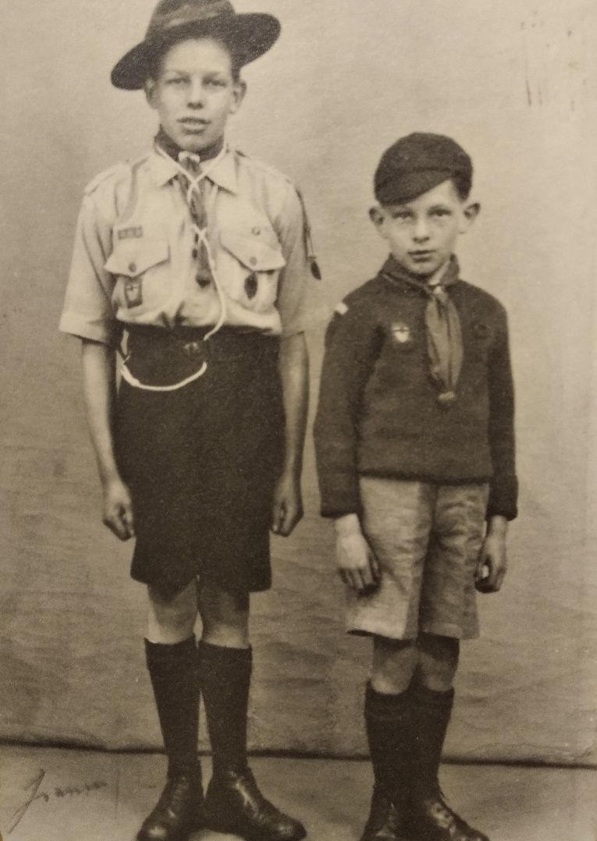 | The fourth photo, left, is of him and me, taken in, probably, 1948.  All scouts were still wearing shorts then!  The last photo, below, is of us taken in 1953 when he became the Assistant Scout Master.  On the 2nd June 1953, Allan took the troop to London for the Coronation. We, presumably along with other troops, were to sell programmes. We marched up The Mall to the gathering cheering crowds about 6.30 am and spent the day selling both along the section near the palace and in the stands and watching the processions.  I hope this is of interest.  Should anyone from that time contact you I would be interested. I now live in East Sussex.  With best wishes

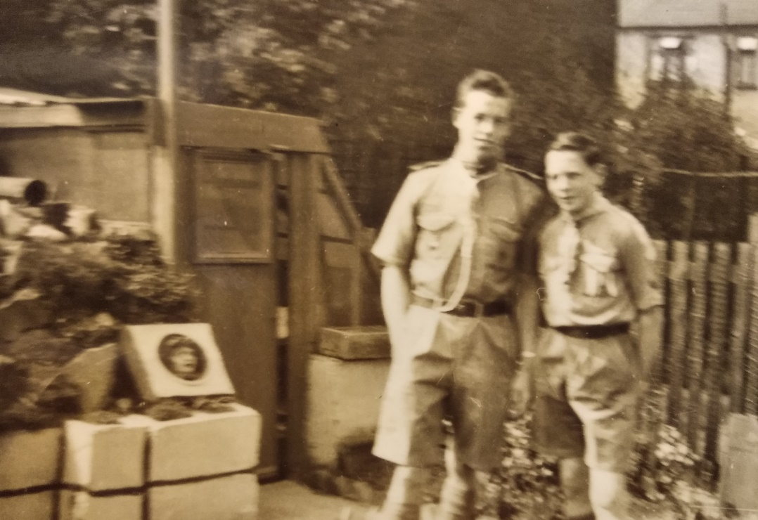

Thinking about fund raising, we had “Bob-a Job” week every year. I'm sure it had to stop many years ago under some child protection law.  During one school holiday, I don't remember which, every scout and cub was expected to raise funds for their group.  Dressed in uniform, we would ask family, friends, neighbours or anyone in the local streets if they had a job we could do, going round either on our own or with another cub or scout. Jobs done were usually simple from sweeping a path, cleaning shoes or brass ornaments, cutting hedges or grass, with a push mower- no electric ones back then. In return you earned a “Bob” (a “shilling”), equal to “5p” in decimal currency. Sometimes, if you were lucky, you would get “two bob”. At the end of the “Job” you gave the “customer” a yellow sticker like the one to the right. | 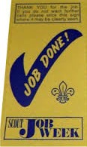

Names from Rudyard Kipling’s “Jungle Book” have been traditionally given to leaders of Cub Packs. Akela is a symbol of wisdom, authority, and leadership. Akela is anyone who acts as a leader. Rudyard Kipling obtained the name "Akela" from Hindi, meaning "alone." In Kipling’s original Jungle Book, Baloo, a sloth bear, is the strict teacher of the cubs of the Seeonee wolf pack.

